RESOLUTION NO.__________

RE: CERTIFICATE OF APPROPRIATENESS UNDER THE
PROVISIONS OF THE ACT OF THE PENNSYLVANIA
LEGISLATURE 1961, JUNE 13, P.L. 282 (53
SECTION 8004) AND BETHLEHEM ORDINANCE NO.
3952 AS AMENDED.

WHEREAS, it is proposed to re-roof the rear addition, replace all windows, repaint the front porch, extend the porch gable, re-roof the porch, repaint the front door, add a screen door, replace the rear door, hang gutters and downspouts at 225 E. Wall St.

NOW, THEREFORE, BE IT RESOLVED by the Council of the City of Bethlehem that a Certificate of Appropriateness is hereby granted for the proposal.

Sponsored by:_

ADOPTED BY COUNCIL THIS DAY OF , 2016

President of Council

ATTEST:

City Clerk

HISTORICAL & ARCHITECTURAL REVIEW BOARD

The applicant proposes to replace the roof on the rear addition, replace all windows, repaint the front porch, extend the porch gable, re-roof the porch, repaint the front door, add a screen door, replace the rear door, hang gutters and downspouts and replace the fence around the yard at 225 E. Wall Street.
APPLICATION #6:

Christa Kanuck
225 E. Wall St.
Bethlehem, PA 18018

OWNER:

__________________________________________________________________________

The Board upon motion by Nancy Shelly and seconded by Marsha Fritz adopted the proposal that City Council issue a Certificate of Appropriateness for the following:

- Replacement windows will be Pella or Norwood windows.

2. The front and rear doors will be SW #7749 Laurel Woods including new screen
door.

3. Exterior trim, siding, gutters, downspouts and roof edge will be SW #7038 Tony
Taupe. Windows to match the taupe color.

4. New roof to be GAF Slateline Antique Gray and include the steeper portion of the
rear addition. Shallower pitched roof will be EPDM roofing.

5. Gutters to be half round with round downspouts and painted to
match the taupe color including the metal drip edge.

6. Light fixtures to be installed at the front and rear doors. The front porch light
fixture will be a recessed down light and the rear fixture may be a wall mounted
fixture know as a “Jelly-Jar” fixture.

7. The motion was unanimously approved.
__________________________________________________________________________

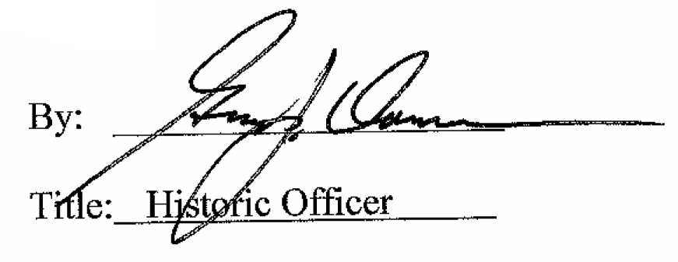

Date of Meeting: April 6, 2016

